Search algorithms

1. Basic search algorithms

* Linear search:
* Binary search:

In a search decision tree with N internal nodes, the **lower bound** is:

or

For all algorithms A that are based in key comparisons.

We can conclude that given this bounds **binary search is optimal**.

1. Search on dictionaries

A dictionary is a sorted set of data that supports the following operations:

* Search(key, dict), returns the position of the key in the dictionary.
* Insert(key, dict), inserts the key in the dictionary .
* Remove(key, dict), removes the key in the dictionary.

We have several options for the data structure of the dictionary:

* 1. **Sorted array**, the search is optimal but the insertion is costly ( Θ(N) very bad).
  2. **Binary search Tree**. In this structure the parent node is bigger than his left child but smaller than his right child.

The cost of a search in a binary search tree is O(height(T)).

The cost of the insertion in a binary search tree is O(height(T)) (being T the tree).

The cost of removing in a binary tree is the cost of searching a key and readjusting the tree.

There are 3 cases when we remove a key:

1. The node we want to remove doesn’t have any child, we just simply remove the child.
2. The node we want to remove has one child, we take that child and we place it in the place were the removed node was.
3. The node has two childs, we need to find a successor, for this we move once to the right and then we keep moving to left until we find a node without any left child.

So, searching in a binary search tree has the following cost (searching in a binary search tree is not the same as doing a binary search, a binary search can be performed in an array):

1. AVL Trees

An AVL tree is a binary search tree in which in every subtree, the balance factor is BF(T’)={-1,0,1}. A balance factor in a node is defined as the height in his left subtree – the height in his right subtree.

In order to build this tree, we follow 2 steps, first we perform the normal insertion in a binary search tree, and second, if it is needed, we rebalance the node with a rotation.

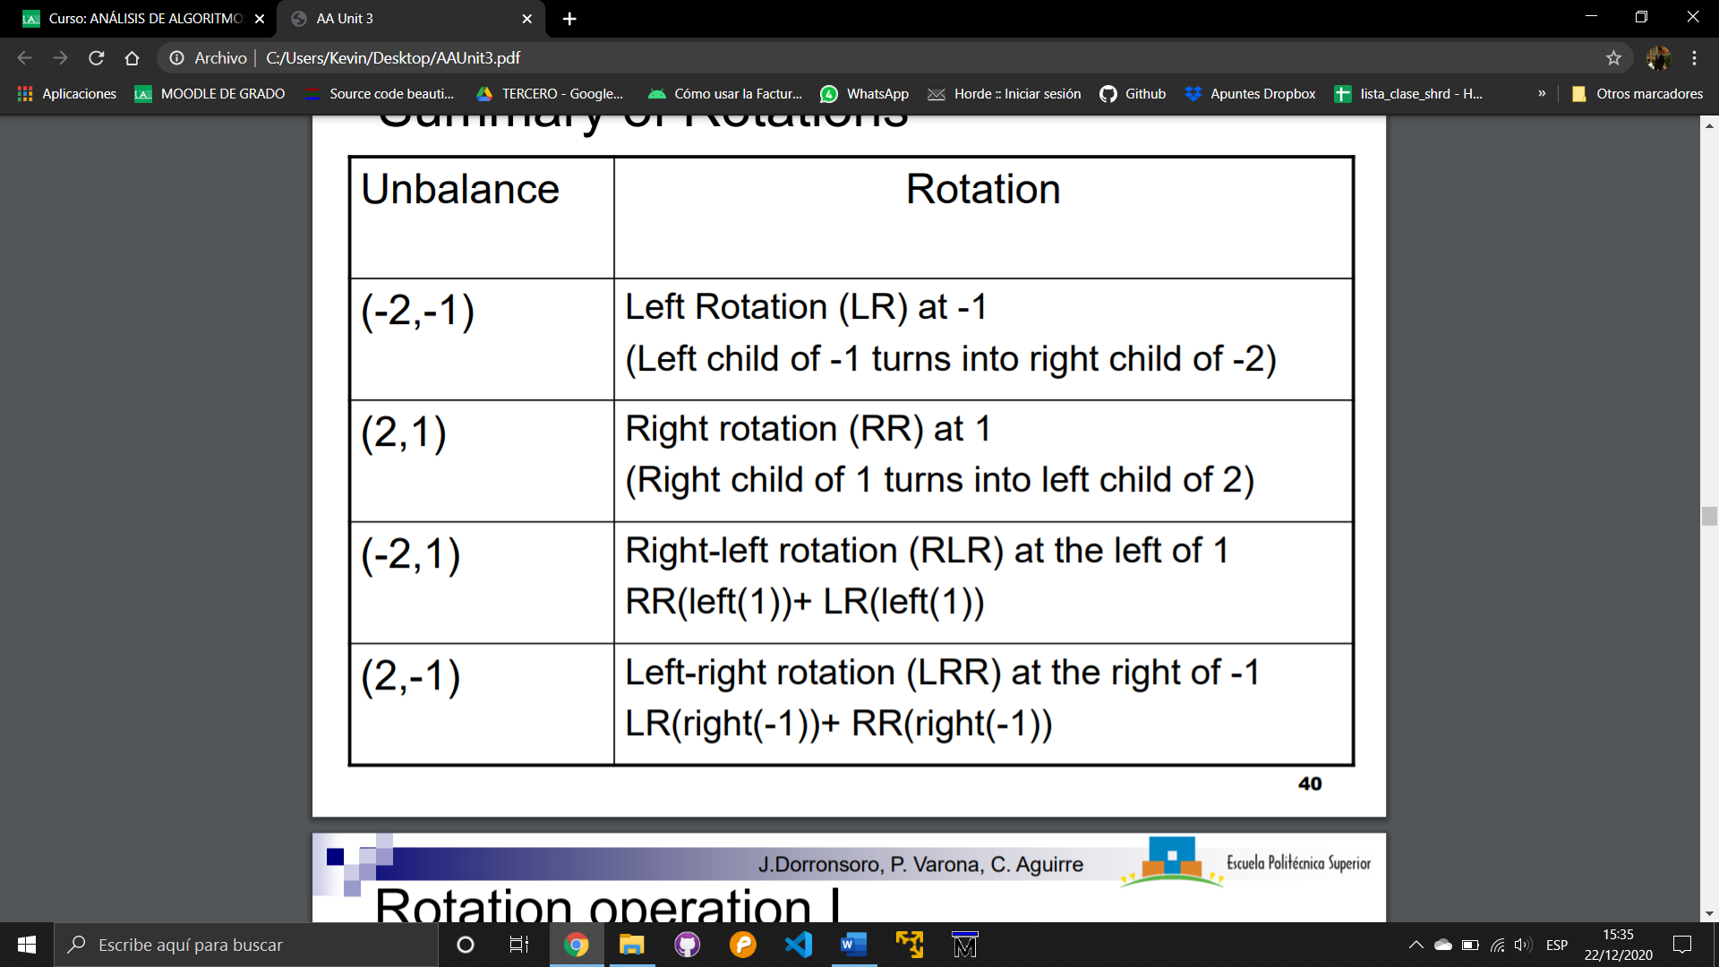

If T is an AVL with N nodes, then height(T)=Θ(log(N)). All primitives related with a binary search tree which is an AVL have a log(N) runtime.

Removing in an AVL tree is different, the common solution is to perform a **lazy deletion**, the node to remove is marked as free.

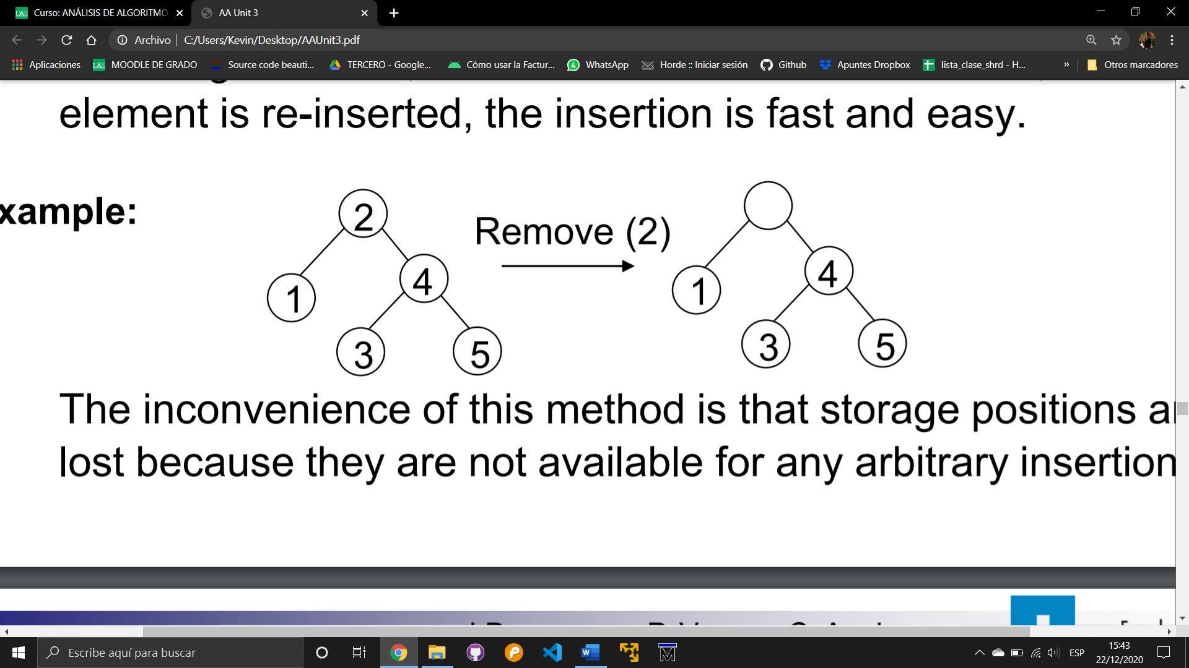

A Fibonacci tree is an AVL tree with the minimum number of nodes for a specific height n. We can see that if we add the number of nodes + number of nodes + 1 for a specific height in a tree Tn, we can see that the result of that addition is the number of nodes +1 of the tree with one node more of height Tn+1

1. Hashing.

With hashing we can search with a cost which is less than O(log(N)).

We have a dictionary with **data** **D**, each data has a unique **key k=k(D)**, so we search **by keys** but **not through keys**.

We have several ways of implementing hashing:

* 1. We calculate k*=max{k(D): D }, we store each D in an array T of size k* (assuming that there are not repeated keys).

With this the cost is O(1), but if k* is too large then the amount of memory to store the array is excessive.

* 1. We fix M > and we define an injective function where if so **k**:{k(D)/D}🡪{1,2,3,…,M}.

Now we place D at the index **k**(k(D)) in the array T.

So, searching is done in a constant time with a reasonable memory consumption. The problem is that it is very hard to find such **injective and universal function**.

* 1. We search for a universal **k** universal function (valid for any set of keys), and we allow that **k**  is not injective. Now it is possible to have **collisions** because , so we have to implement a mechanism to deal with collisions and create a hash function.

When we create hash functions, our goal is to have the less possible collisions. So, we have an array T with M data, this means that **p(collision)=1/M**. One way for implementing this function is to use random indexes using rand().

Another way is using divisions, so where **m** is prime, then we define **h(k)=k%m**.

Another way is using multiplications, so and we have Φ as an irrational number equal to or , then we define **h(k)=**

Let’s now define a **uniform hash function**. A hash function is uniform if given k and k’ where kk’, then p(h(k) = h(k’)) = 1/m

In order to solve collisions, we do it in these ways:

* **Chaining**: If we have a collision, we create a linked list.

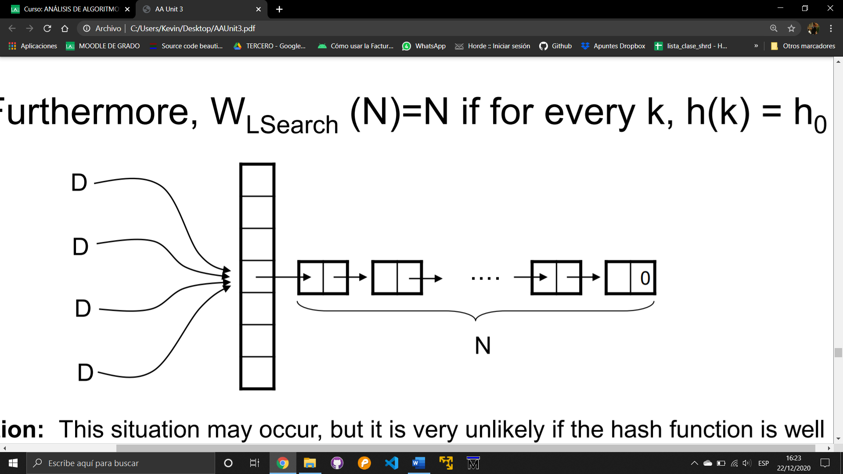

The search on average is:

In the **failure** case:

In the **successful** case:

* **Open addressing**: We have several methods in open addressing, but they are all related with **probing**, which is that if the place we want to store the key is occupied we search for another place.

In **linear probing**, if we have a collision, we store the data in the next free space. p=T[h(D)], (p+1)%m if this is occupied then (p+2)%m,… until we find one free.

In **quadratic probing**, we do the same as in linear probing but in positions (p+12)%m,…

In **random probing**, we try random positions. In case we use random probing, we have that:

and

The Average cost in probing methods is:

In the **failure case**

In the **successful case**